Automation Scripts POSTMAN-Screenshots:

Create of scripts:

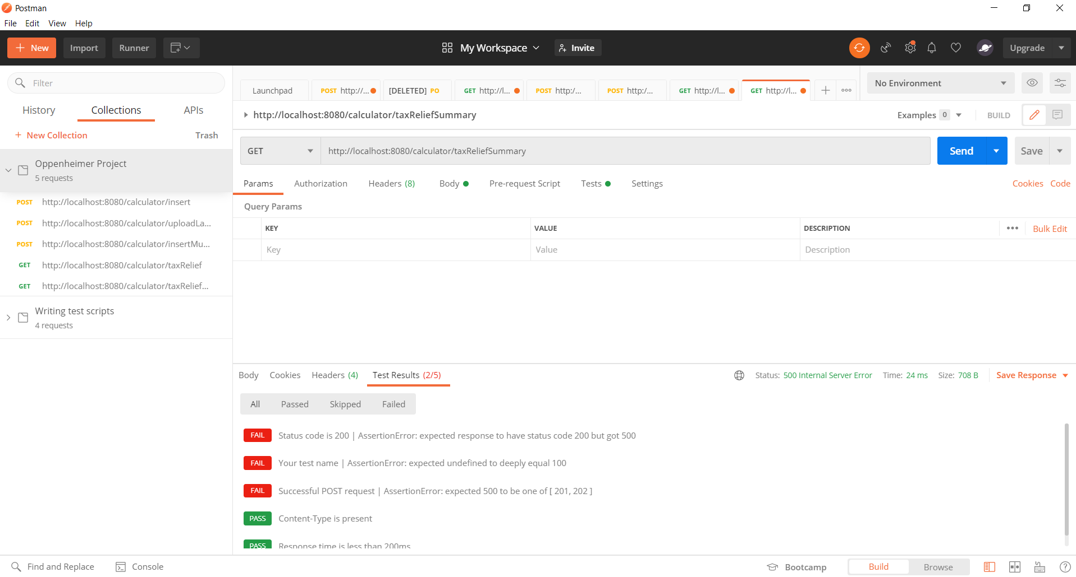

Result:

1. Click Runner on Postman home screen to test all the API Calls.

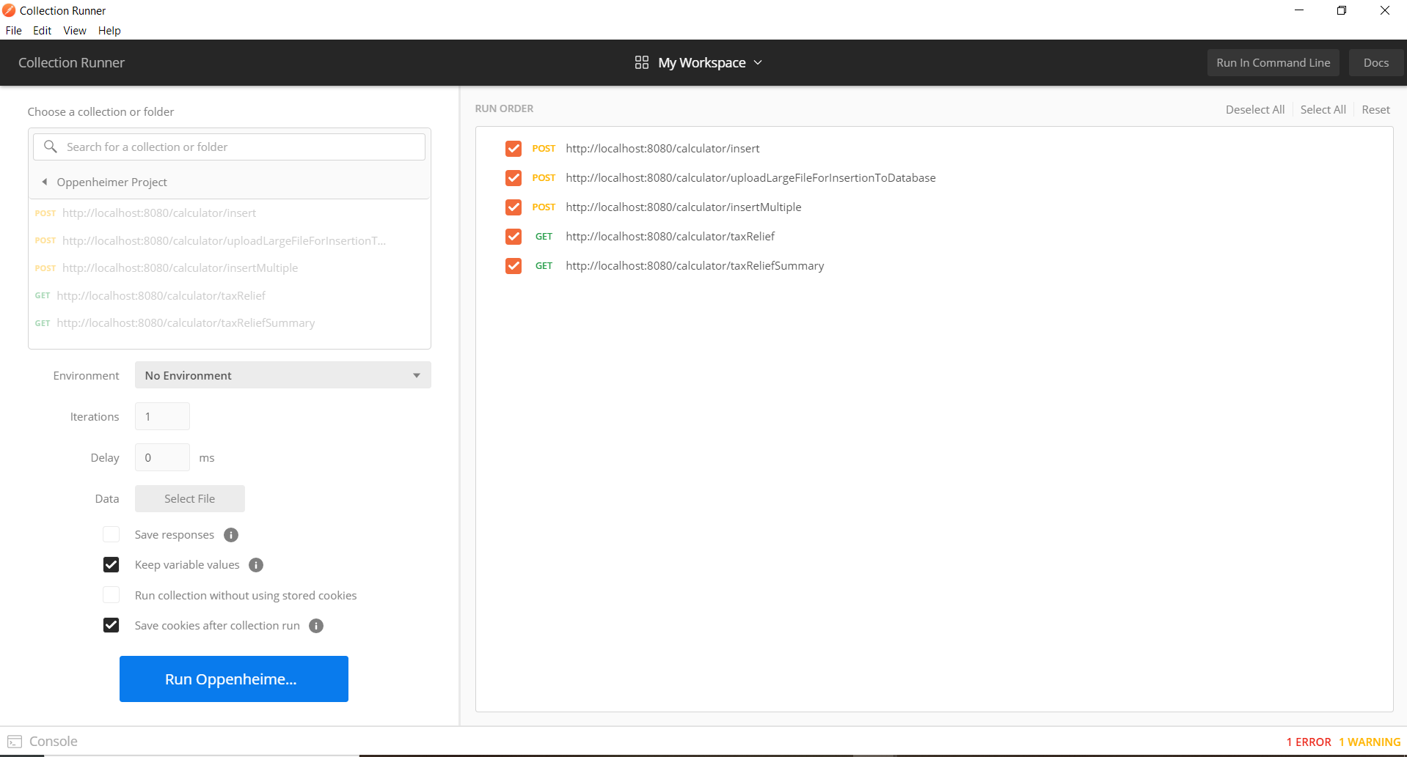

1. Click the “Run Project name” Button at the bottom.



1. The result will be shown in below page

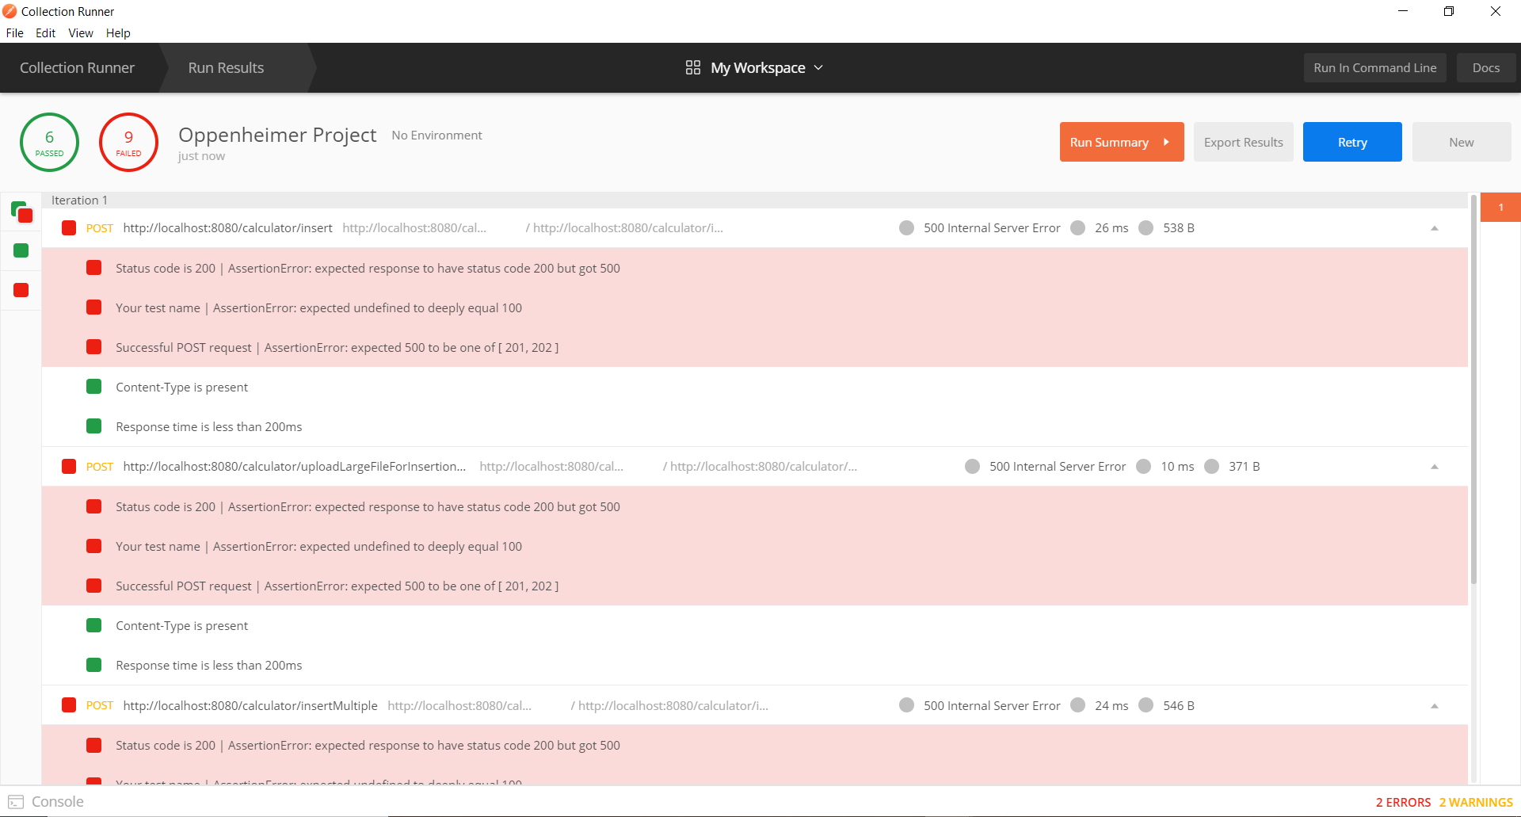

1. Click “Run Summary” to view the summary of the result. The result summary will be shown below.

